Question : **Discuss how you would rule out other measure the size of these remaining threats.**

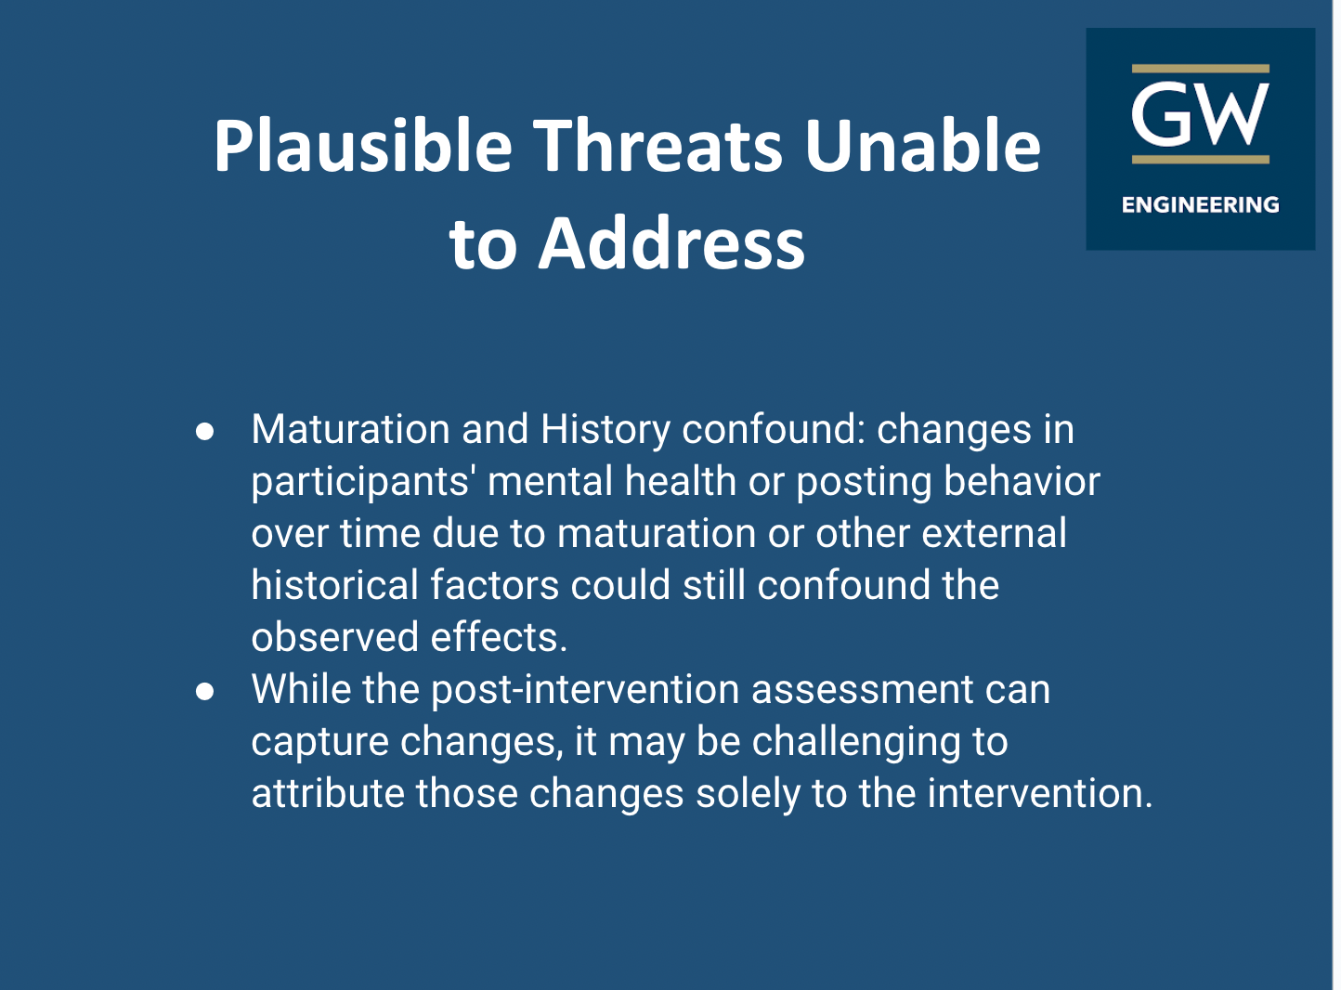

**For remaining threats, we understand that ruling out the size of threats is impossible as maturation and history confound cannot be controlled. As doing so, we mentioned how maturation or external historical factors could still be confound factors that post intervention assessment can capture changes but it still be challenging to attribute those changes solely to the intervention.**